**NAME:**

**PROBLEM 1:**At a point in a loaded member, the stresses relative to a x-y-z coordinate system are given by:



**1a.** Draw the state of stress on the cube shown and determine the principal stresses for this state of stress and their directions cosines. (If you use MATLAB or Excel to perform calculations, be sure to print out the Command Window or spreadsheet that contains the commands you used to perform the calculations.)

**1b.** What angles (in degrees) do each of the principal stresses make with the x, y, and z axes?

σ1: θ1x= θ1y= θ1z=

σ2: θ2x= θ2y= θ2z=

σ3: θ3x= θ3y= θ3z=

**1c.** Determine the transformation matrix from the original state of stress to the principal state of stress and prove that it is the transformation matrix by using it to transform the original state of stress to the principal state. Illustrate the stress cube the represents the principal state of stress.

**1c.** What is the absolute maximum shear stress and the normal stresses that accompany it? Illustrate the stress cube in this state.

**1d.** What angles does the absolute shear stress make with the x, y, and z coordinates

τmax: θx= θy= θz=

**1e.** Determine the stress invariants for the states of stress for the original stress state, the principal stress state, and the state of stress that contains the maximum shear stress. What is the relationship between the invariants in these three states of stress?

**PROBLEM 2:** The circular beam shown in the figure below is fixed into the wall at A and has a force  and moment applied to the end at B.

.5 m

75mm

2000N

1000N

5000N-m

1000N

y

z

x

A

B

.5 m

75mm

2000N

1000N

5000N-m

1000N

y

z

x

A

**y**

**A**

**x**

**z**

**y**

**2a.**  Using the bottom figure on Page 7, complete the free body diagram of the circular beam. Using the top figure on page 8 illustrate the resultant internal forces and moments in the beam at the wall.

**z**

**A**

**2b.** Using the lower diagram on Page 8 illustrate the natural axis, include the angle it makes with respect to the y or z axes, and identify the location where the normal stress will be maximum.

**2c.** Draw the complete stress cube for the location of the maximum normal stress on this surface.

**2d.** Using the state of stress illustrated in the previous part, draw Mohr’s circle and determine the principle stresses, maximum shear stress, normal stress corresponding to the maximum shear and the angles these states of stress make with the original states of stress. Draw a stress cube 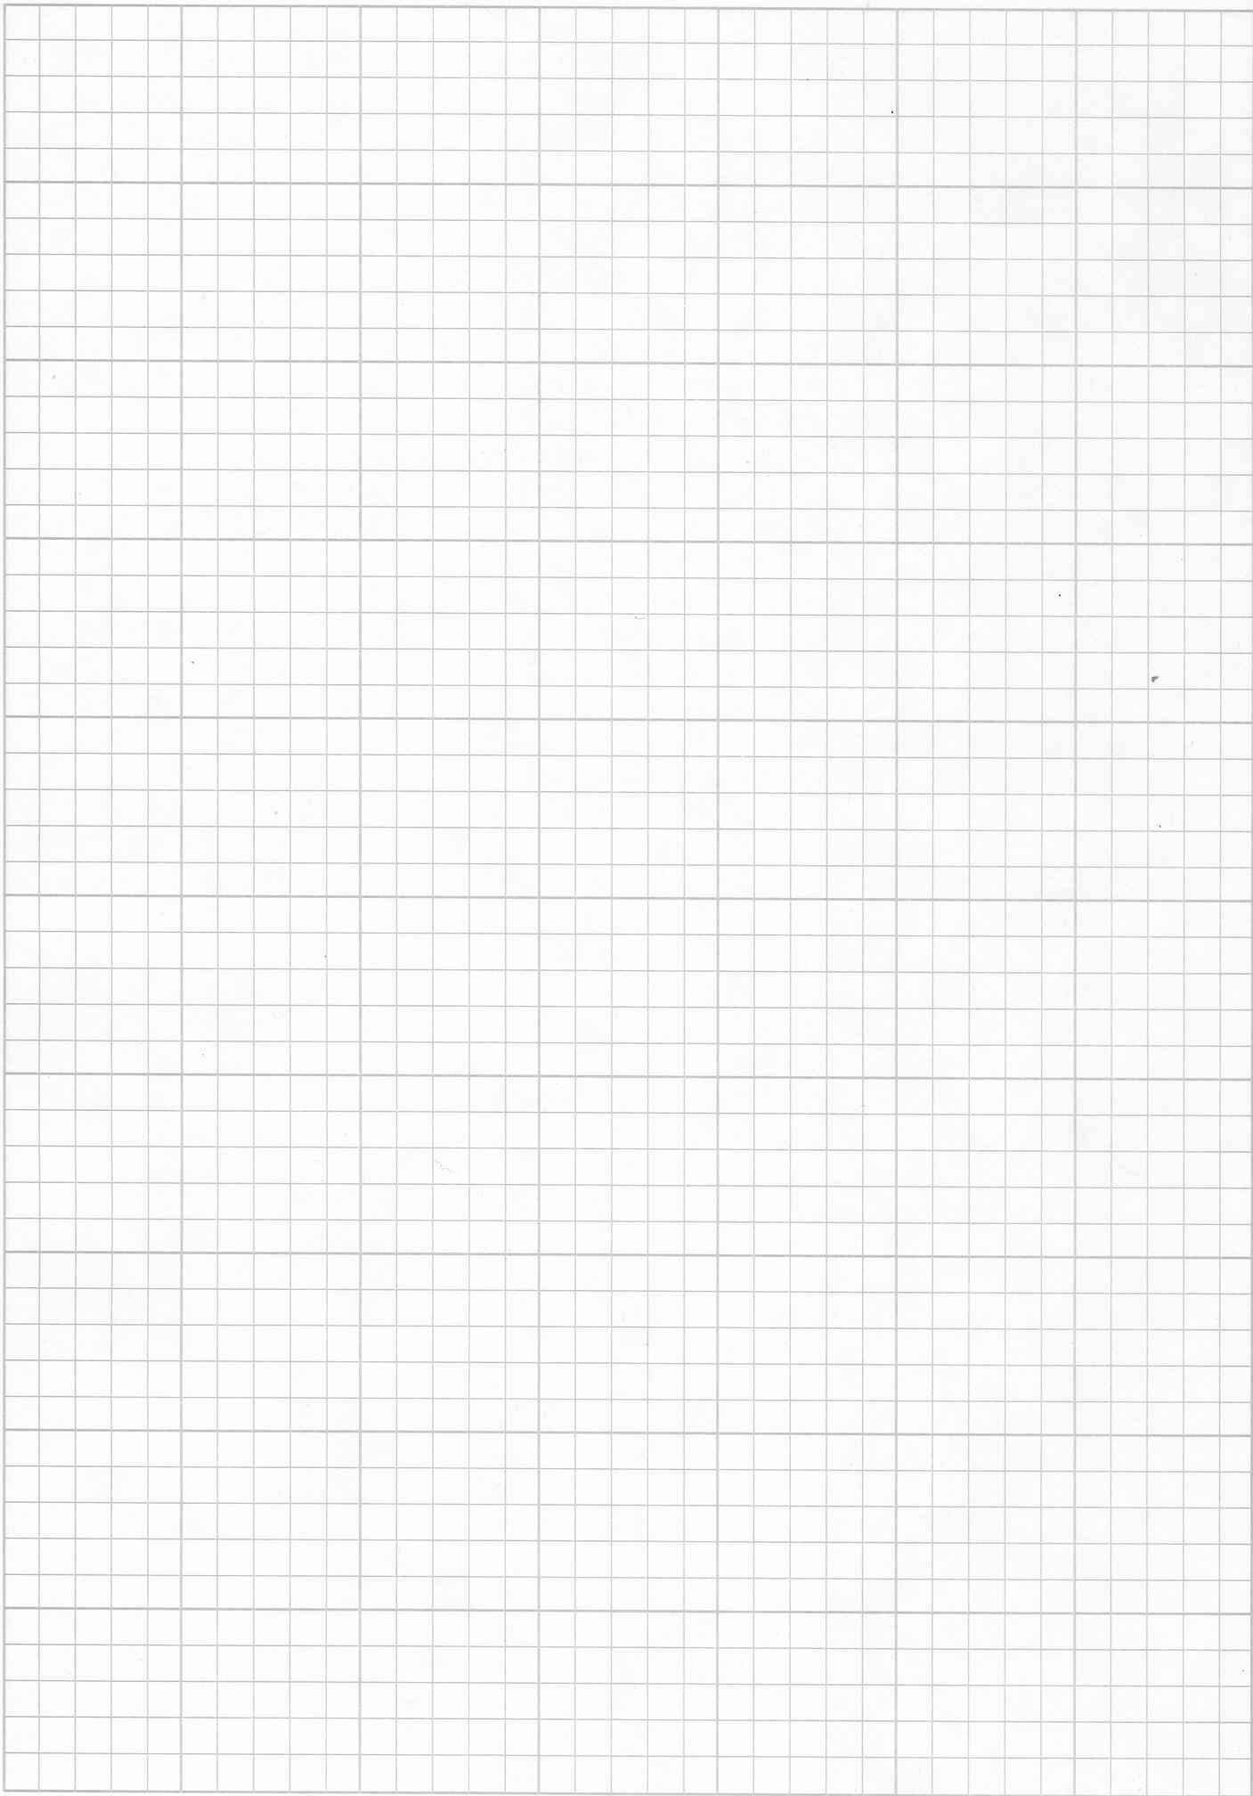that illustrates both states of stress relative to the original state of stress.